College of Saint Benedict & Saint John’s University

Computer Science Department

GABeS

Phase 4

Team Potatoes

Grant Boyer, Kyle Olson, Tom Husen

[This page has been intentionally left blank]

Table of Contents

Database Design ……………………………………………………………………………………………………………………... 4

EER Diagram ………………………………………………………………………………………………………………... 4

Relational Map Diagram ...…………………………………………………………………………………………... 5

Physical Database Design ………………………………………………………………………………………………………… 6

System Functionalities ……………………………………………………………………………………………. 7-10

SQL Code Components ………………………………………………………………………………………………………….. 11

Triggers ……………………………………………………………………………………………………………………… 11

Stored Functions ………………………………………………………………………………………………………… 12

Stored Procedures ………………………………………………………………………………………………… 13-14

Views …………………………………………………………………………………………………………………………. 15 Sequences …………………………………………………………………………………………………………………. 16

Issues Faced During Phase .………………………………………………………………………………………………….… 17

Task Decomposition …………………………………………………………………………………………………………….… 18

Meeting Minutes …………..…………………………………………………………………………………………………….… 19

November 8, 2016 ..……………………………………………………………………………………………………. 19

November 13, 2016 ……………………………………………………………………………………………………. 20

November 14, 2016 ……………………………………………………………………………………………………. 21

Appendix …………..………………………………………………………………………………………………………………..… 22

A ..………………………………………………………………………………………………………………………………. 22

B ..………………………………………………………………………………………………………………………………. 23

C ..…………………………………………………………………………………………………………………………. 24-26

Reflection

In the fourth and final phase of our database systems project we were able to accomplish so much more than we ever anticipated when we began this project more than three months ago. From the beginning steps of trying to understand what this ‘GABeS’ system was all about, to designing a fully functional and beautiful website of our own we have learned and accomplished so much.

In our final submission, we have completed all of the base requirements as well as additional ones.

One of the few things we omitted was the use of two distinct login pages. We approached this project from the view of a potential client or end user who would end up using this website on a regular basis. What we decided was it is very important for an admin to be able to accomplish things a standard user cannot, but it is also important that an admin is able to interact with the system in the same ways a standard user can as well. With this in mind what we did was incorporate the admin functionalities into a menu drop-down from our main menu bar. A variable within the *User* JavaBean establishes whether the currently logged in user is an admin or not, and only displays accordingly. By omitting distinct login pages, we were able to make our system more efficient by eliminating redundant pages and simultaneously significantly improving the end users experience when interacting with the site – both as an admin or as a standard user.

In addition to the extra GABeS functionalities we added, which will be discussed later in this report, we also added several elements to our website to improve the quality of our final product. One such feature is related to leaving feedback for an item that you have won. Once you win an auction, the newly won item will move from *Items I’ve Bid On* to *Item’s I’ve Bought*. When visiting the second page there is a button for you to add feedback about the transaction. One thing our group added to this page was that once a user has left feedback about a transaction, rather than seeing a button to leave feedback, they will see a message thanking them for already leaving feedback about this transaction. This ensures no conflicts within the database, as well as allows the user to quickly and easily see which transactions they have and have not left feedback for.

Issues Faced

During this phase we faced many different issues stemming from SQL Developer not working properly to figuring out how on earth everything would be connected and come together. Ultimately, we were able to vanquish many of these issues and by not cutting corners and working our hardest to ensure our solutions were both efficient and forward thinking, we will be saving ourselves lots of work in the next phase as well as making our product more complete.

When we began working on this phase, we started by going through every website that we designed during Phase 1. For each webpage we discussed what exactly the purpose of that page was, and how we though to best accomplish that in terms of SQL implementation. Then we divided all of the tasks so each team member could work on their tasks before bringing them all together into final products. For some of these, issues arose when trying to implement our initial implementation idea so we had to bounce ideas off each other to determine what would actually be the best approach to the problems. This collaboration about our ‘separate’ parts of the project was immensely helpful as they often applied to more than one task which caused us to be consistent across the board when it came to the implementation.

Another problem we faced was a couple times when testing a SQL query on our team server, we experienced lag and sometimes crashing of our Horizon Client that was running on our personal computer (though not necessarily VMware’s fault). While there is nothing we could really do at the time of crashing, we agreed that if we were each to have a copy of the databases on each of our individual Oracle DB connections, we could test our queries/functions/procedures/etc. without these bugs happening. Once we determined that the process worked properly on our own DB connection we would sync it with the team connection.

When working on the Bid on Item functionality, we were planning on using a Scheduler to execute a stored procedure every 5 seconds or so because that seemed like the best way to do psudo-live checking of the time. When we tried creating the scheduler we ran into permissions issues and the Oracle server wouldn’t allow us to create or run the scheduler we needed. The code that we would have used is listed in Appendix A. We created a work around that does work but it doesn’t check every 5 seconds like we had hoped. Our hope is we can straighten out our scheduler and implement that in Phase 4.

Task Decomposition

Grant:

* Feedback JavaBean
* Admin Sales Summary
* Admin Commission Report
* View My Feedback
* Add New Feedback

Kyle:

* Bids JavaBean
* List My Items
* Show Item’s Info
* List of Items User Bid on
* List of Items User Bought
* List of all Items for Sale
* Edit Item’s Info
* Show List of Bidders for an Item
* Bid on an Item

Tom:

* User and Item JavaBean
* Add New User
* Add New Item
* Update Profile
* Login/Logout
* Search

All Team Members:

* Populated beans with methods pertaining to our respective functionalities
* Normalized the tables from our database
* Implemented an extremely user-friendly UI using in depth CSS/HTML

Team Potatoes Minutes

November 8, 2016

Meeting began at 3:45 am.

**In Attendance**:

* Grant Boyer
* Kyle Olson
* Thomas Husen

**All**:

* Discussed all of the elements that goes into this phase and the best approach for completing them
* Began creating database tables and populating them with sample data values
* Discussed our relational map and EER diagram as they relate to the database and began making appropriate changes

Meeting adjourned at 5:30 am.

Meeting Minutes

Team Potatoes Minutes

November 6, 2016

Meeting began at 4:30 pm.

**In Attendance**:

* Grant Boyer
* Kyle Olson
* Thomas Husen

**Tom**:

* Update EER and Relational Map based on our most recent decisions regarding our database

**All**:

* Review all webpages created during Phase 1 – generate spreadsheet breaking down each page to the tasks it needs to accomplish, how we think to best accomplish that task, comments about the task, and who is going to be responsible for completing that task – Appendix B
* Discuss any changes that are required to be made on the EER diagram or the Relational map

Meeting adjourned at 11:30 pm.

Team Potatoes Minutes

December 7, 2016

Meeting began at 9:00 pm.

**In Attendance**:

* Grant Boyer
* Kyle Olson
* Thomas Husen

**Grant**:

* Finishing touches on leave new feedback functionality
  + - Added restriction about reviewing a transaction multiple times
  + Began generating information for the phase report

**Kyle**:

* Continue work on editing an item’s info.
* Put finishing touches on bidding functionality

**Tom**:

* Continue work on search functionality
* Compile various versions and various files into our master repository

**All**:

* Continued testing the website, trying out many different scenarios to improve reliability and consistency throughout the entire user experience
* Assisted each other with any blockers they experienced with their assigned tasks
* Continued implementing CSS styling throughout the site

Meeting adjourned at 12:00 am.

Appendix A:

[Link to Full Spreadsheet](https://docs.google.com/spreadsheets/d/1pejnJdGgBSz0PK1PAWdoMoDXfXdx-fRefrvWnf6iepg/edit?usp=sharing)

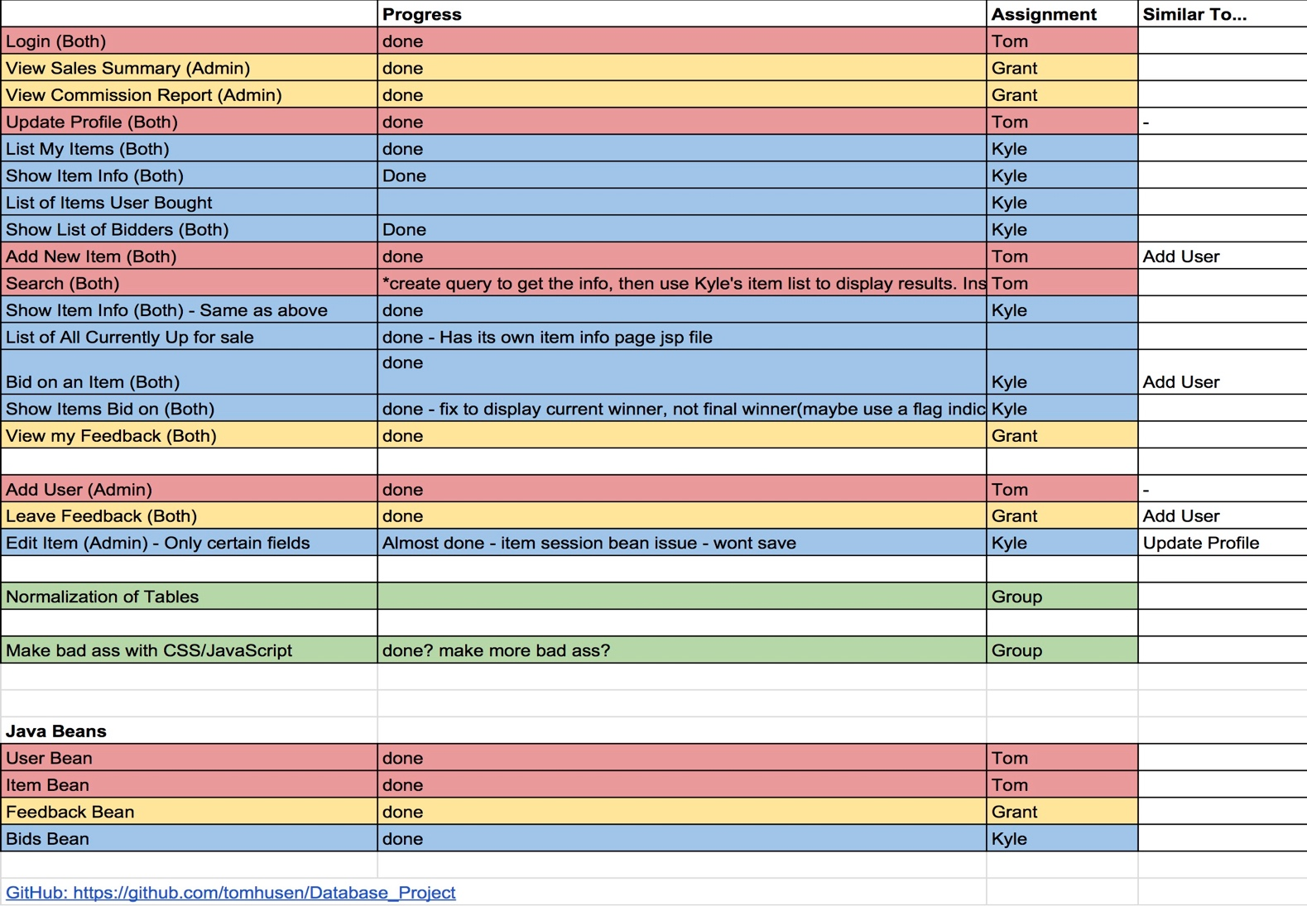

Appendix B: